Value Based on matrices:
- COM- Neighborhood Shopping Center (412) [Base unit cost]
- COM – Section 13 Height Multipliers
- COM – Section 1 FAP Multiplier [Floor/Area Perimeter]
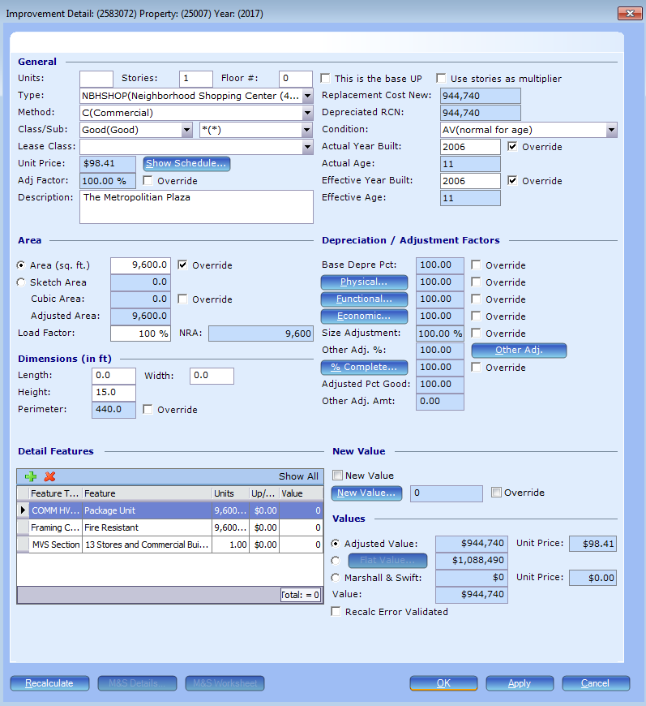

$944,740 (tested by hand and these 3 matrices are working properly)

Value after adding matrix COM – Section 13 HVAC MODWFU-addition
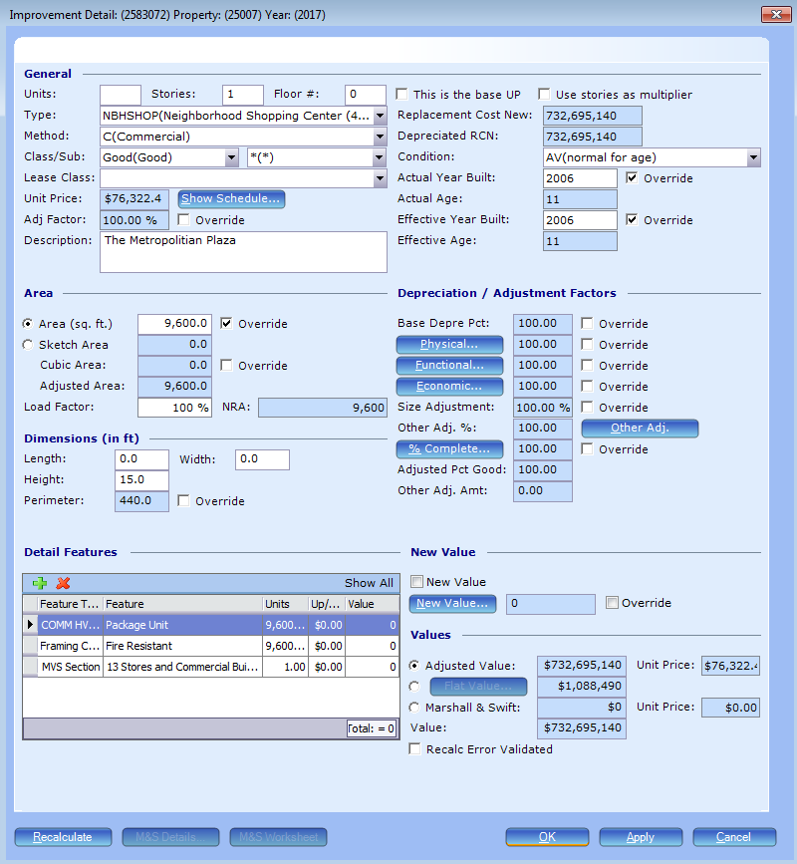
$732,695,140
9600(feature units) x 7.94(rate) x 9600(building area) + 944,740 (running base cost) = $732,695,140
Note: The value changes proportionally if the COMM HVAC feature units and/or the area is changed, so based on how it’s set up now it is multiplying the rate times both the feature units and the building area.

Schedule and Matrices
NBHSHOP Schedule
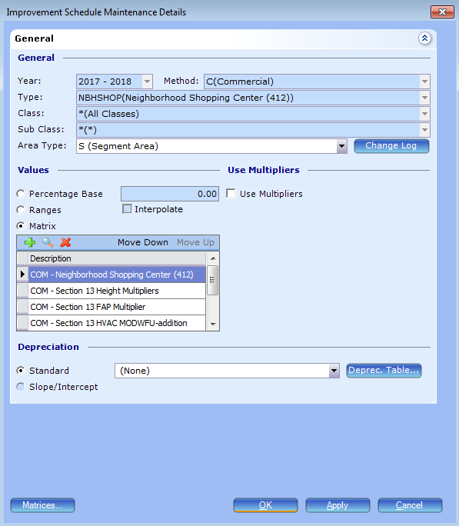

COM – Neighborhood Shopping Center (412)
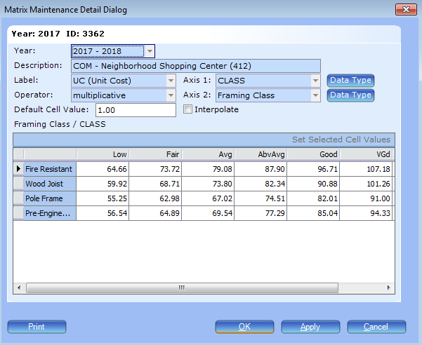

COM – Section 13 Height Multipliers
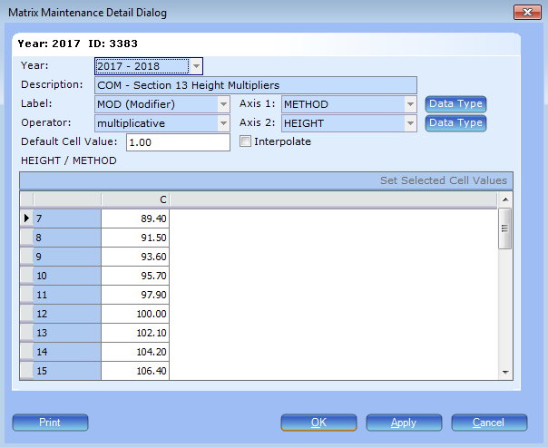

COM – Section 13 FAP Multiplier
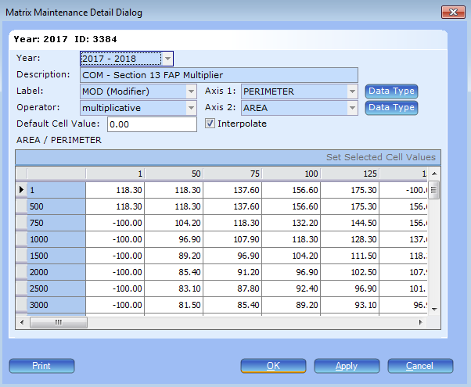

COM – Section 13 HVAC MODWFU-addition
